KE5Z -

Functionality
This transaction calls up an actual line item report. G/L record type (0 = actual, 2 = actual assessment/distribution within Profit Center Accounting).

Scenario
You want to display all actual line items in version 0 coming from billing documents in period 7, year 2002.

Requirements
Any document was posted.

Menu Path | SAP menu → Accounting → Controlling → Profit Center Accounting → Information System → Line Item Reports → KE5Z - Profit Center: Actual Line Items
Transaction Code | KE5Z

1. Double Click on KE5Z - Profit Center: Actual Line Items

Profit Center: Actual Line Items

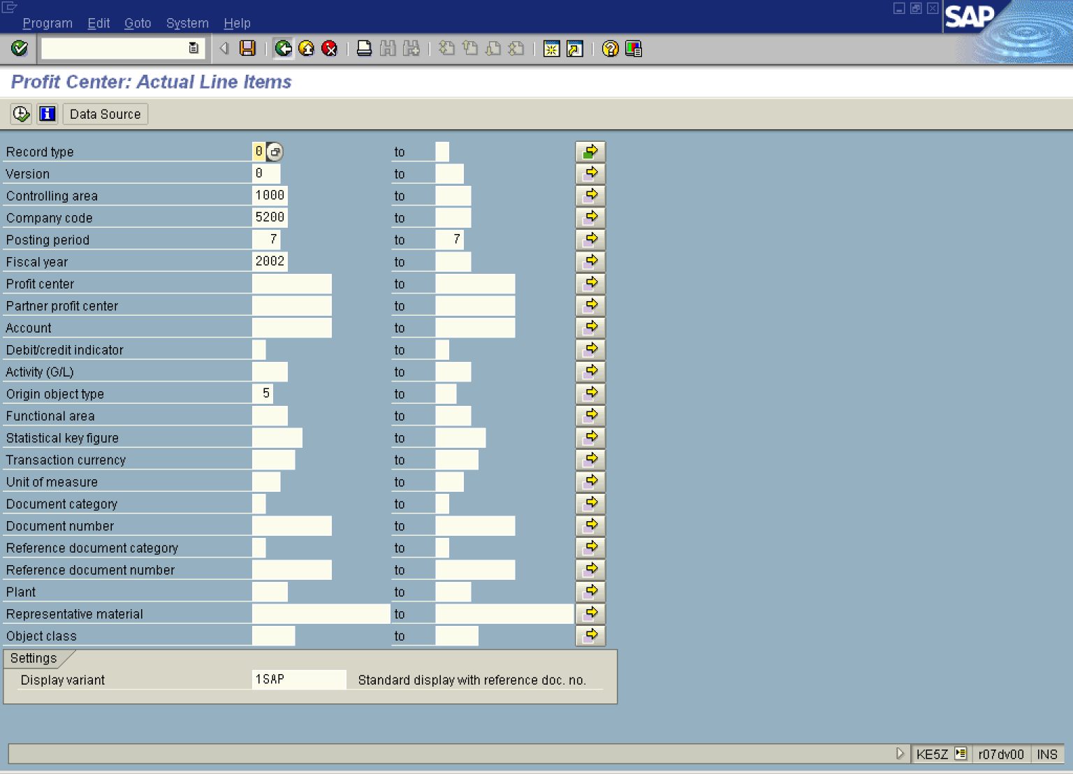

2. Update the following fields:

Field Name | Field Description | Values
Controlling area | Code identifying the highest level of the legal entity for which cost center accounting and profit center accounting can be consolidated | Example: 1000
Company code | Organizational unit within financial accounting. | Example: 5200
Posting period | Interval of relevant periods | Example: 7
Fiscal year | Relevant Fiscal year. | Example: 2002
Origin object type | Origin object type, i.e. ‘2’ Cost Center from which values come | Example: 5 (billing document)
3. Click .

Profit Center: Actual Line Items

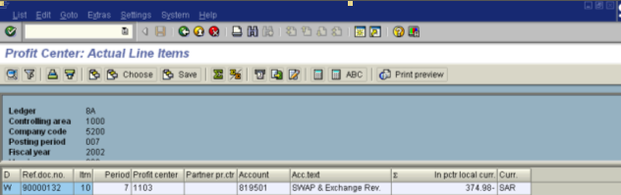

4. Double Click on the marked line in the field ‘Ref. Doc. No.’.

Invoice 90000133 (F2) Display: Overview of Billing Items

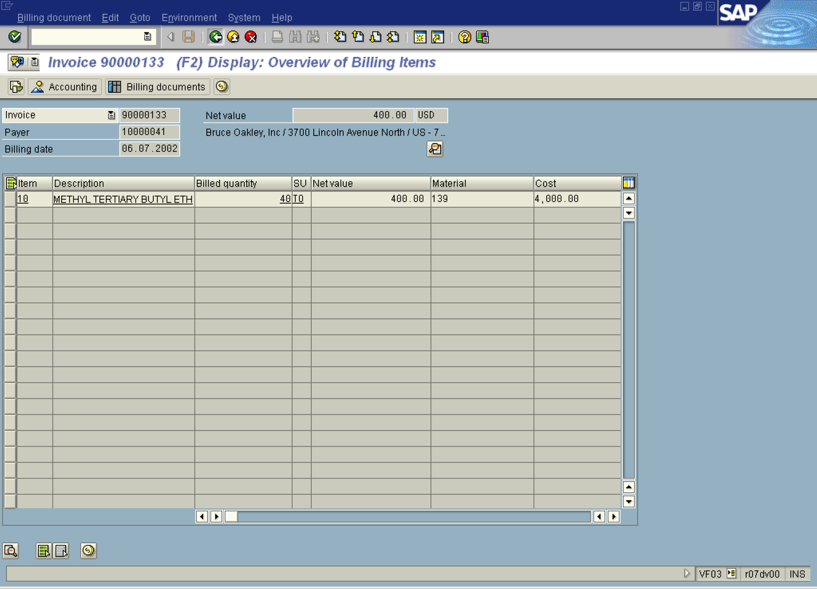

5. Click Back .

Profit Center: Actual Line Items

6. Click Back .

